Source 1
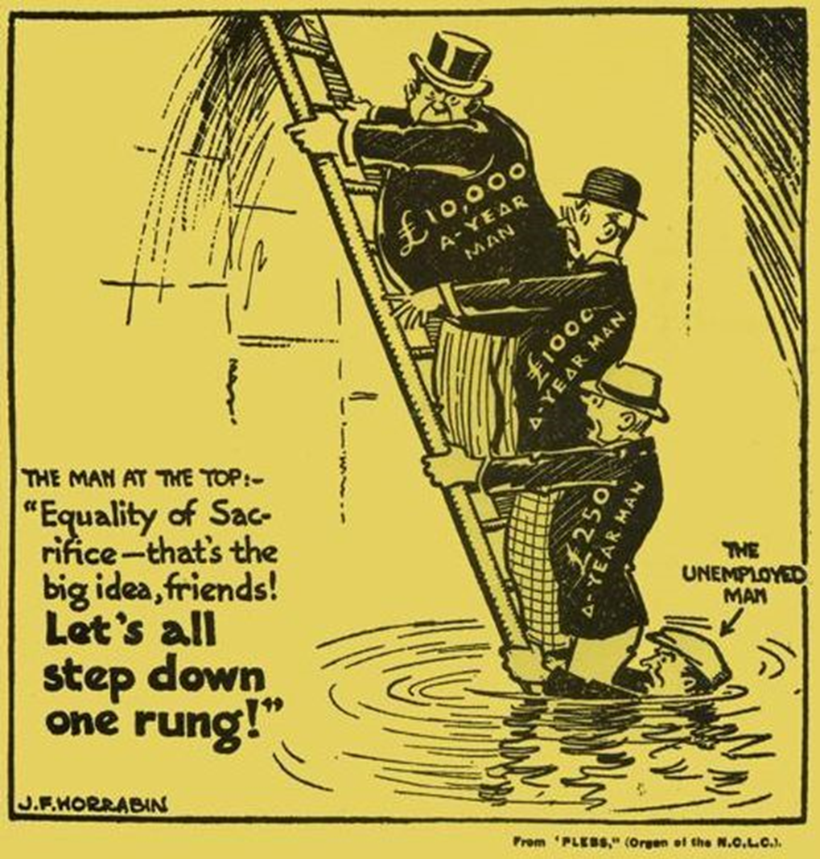

Publication in The Guardian newspaper, 1930

Source 2

Source 3

The United Australia Party, in common, I believe, with the great majority of the electors of Australia, welcomes this election. It gives us an opportunity of placing before the people the choice between sound honest finance and government as against fantastic schemes of inflation and political control of currency and credit.
Our kinsmen in Britain have just emerged triumphantly from such a test as that to which our Australian electors are now to be put. I feel sure that the sturdy and solid commonsense which is characteristic of our race will assert itself here as it has in the Motherland………
I do not say that Mr. Scullin and his colleagues were responsible for the depression, or that they were responsible for the beginnings of the abnormal unemployment, but I do say that they have by their conduct enormously aggravated and increased the depression, and that they have been directly responsible for the unemployment of scores of thousands of good Australians who are now idle and destitute. That is my charge against the Government, and that is why I left the Government, and why we of the United Australia Party deemed it our duty to defeat the Government and bring it before its masters in the country.

Joseph Lyons United Australia Party, Delivered at Sydney, NSW, December 2nd, 1931
The election was held on 19 December, 1931. The Great Depression was at its height and dominated the election campaign.

Source 4

While the Government was patiently unravelling the tangled financial skein, and working for a revival in industry, opponents were careering round the country spreading party propaganda and rendering the task of the Government more difficult.
Newspapers with a few notable exceptions, hurled criticism and invective against the Government. Abusive epithets were applied to me personally because I determined to maintain allegiance to the party to which I am pledged. The formation of a Coalition Government in Britain was thrust forward as an example. The Coalition Government in Britain, however is now only setting out to balance trade and balance the Budget. The Labour Government has successfully done both these things and preserved its political identity.
On election day you have to decide between the Opposition and the Government. What guarantee have you that the combination of Opposition forces would not carry out their former intention to destroy Federal arbitration? What undertaking do they give that they would not pull down the tariff wall to its former level and expose Australian industries to ruthless competition?

James Scullin Australian Labor Party, Delivered at Melbourne, Vic, December 1st, 1931

